Physical and Chemical Change Revision Quiz

- Identify the state(s) of matter in which the particles take the shape of the container.
- Liquids and gases
- Gases only
- Liquids only
- Liquids and solids

- Define diffusion
- Diffusion is when particles in a liquid or gas mix evenly through random motion.
- Diffusion is when particles can be compressed.
- Diffusion is when particles cannot be compressed.
- Diffusion is when particles have a large amount of space between them.

- Identify what happens when a substance dissolves
- The particles of a substance disappear in water.
- The particles chemically react with water.
- The substances changes state.
- The particles of the substance are distributed evenly through particles of another substance.

- Recall the effect that heat has on the energy of particles.
- Heat causes the particles to change shape.
- Heat causes the particles to change state.
- Heat causes the particles to move faster.
- Heat causes the particles to melt.

- Identify the name of the process that occurs when a solid carbon dioxide (dry ice) is converted to gas.
- Evaporation.
- Boiling
- Sublimation
- Melting.

- Identify the correct statement(s) for the particle theory of matter.
- The particle theory of matter states that all matter is made up of particles.
- All the answers are correct
- The particle theory of matter states that particles of matter are constantly moving.
- The particle theory of matter explains the behaviour of solids, liquids and gases.

- Explain why metals expand when heated.
- The particles gain energy and move further apart.
- The particles gain energy and get larger.
- The particles lose energy and get larger.
- The particles lose energy and move further apart.

- There are ways to tell if a chemical reaction has occurred. Identify which of the following is NOT one of these
- The reaction vessel becomes hotter
- There is a change of state
- A gas is produced
- A precipitate forms

- Identify which of these reactions is endothermic
- A sparkler producing coloured lights.
- Burning a lump of coal
- Photosynthesis
- A lit candle of a birthday cake

- Identify which of the following is not a sign of chemical change.
- A solid precipitate or gas is produced.
- There is a permanent colour change
- Energy is produced or absorbed
- A mixture forms

- Identify which of the following is a different substance (contains different types of particles) to the others
- Ice
- Water
- Air
- Steam

- Identify which of the following are difficult to compress.
- Only solids
- Solids and liquids
- Liquids and gases
- Solids and gases

- Identify the correct statement. The melting point of a substance is the:
- Part of an object that first turns to liquid.
- Temperature at which a substance begins to melt
- Time taken for a substance to fully melt
- Place where it is when it melts.

- Identify the correct statement. Evaporation is:
- The same as solidification
- Something that happens to gases
- When small bubbles begin to appear in a liquid.
- Another term for vaporisation.

- Identify the correct statement. Dew on the grass in the morning after a cold night is the result of:
- Sublimation
- Diffusion
- Evaporation
- Condensation

- Determine which of the following is the least expensive form of rust protection.
- Alloying
- Galvanization
- Chrome plating
- Painting.

- Identify which of the following are units of density.
- Kg/m²
- M³/kg
- Kg/m³
- m/kg³

- Identify the correct statement about density.
- Lead has a lower density than water.
- A large piece of copper is denser than a small piece of copper.
- A solid has a higher density than any type of liquid.
- A copper coin has the same density as a copper cube.

- Identify the correct statement. An object will float if its density is:
- Lower than that of the liquid it is in.
- Less than 1 g/cm³
- The same as that of the liquid it is in.
- Higher than that of the liquid it is in.

- Identify where the heat given off by an exothermic reaction comes from.
- Atoms that are destroyed during the reaction and converted to energy.
- The collisions between atoms and molecules.
- The energy stored in the chemical bonds of the reactants
- The surroundings (environment)

- Identify the products in the chemical reaction: nitric acid + lithium hydroxide → lithium nitrate + water
- Nitric acid and water
- Nitric acid and lithium hydroxide
- Lithium hydroxide and lithium nitrate
- Lithium nitrate and water.

- Determine the formula equation for the word equation: copper sulphate + barium chloride → copper chloride + barium sulphate.
- CuSO₄ + Ba(OH)₂ → Cu(OH)₂ + BaSO₄
- CuSO₄ + BaCl₂ → CuCl₂ + BaSO₄
- H₂SO₄ + CuCO₃ → CuSO₄ + CO₂ + H₂O
- CuCO₃ + BaCl₂ → CuCl₂ + BaCO₃

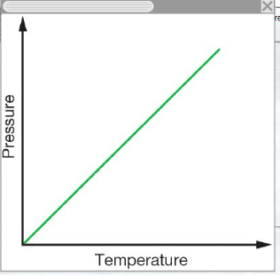
- Deduce from this graph the relationship between pressure and temperature of a gas in a solid container.
- As the temperature increase, the pressure decreases.
- As the temperature increases, the pressure stays constant.
- As temperature increases, the pressure increases
- As the temperature decreases, the pressure increases.

- Read the data in the table below and identify the correct statement:
- Metals expand less than non-metals
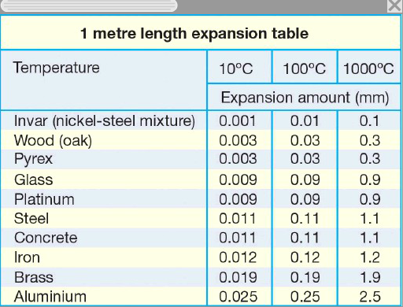
- Aluminium expands more than steel
- Metals expand more than non-metals
- Aluminium expands less than brass

- Explain what is happening in this diagram.
- The atoms in the reacts are being destroyed and the products are being created.
- The atoms in the reactants are rearranging to form the products
- This is a physical change because no new atoms have been formed.
- The atoms in the products are rearranging to form the reactants.


